11

Participant Assent Form
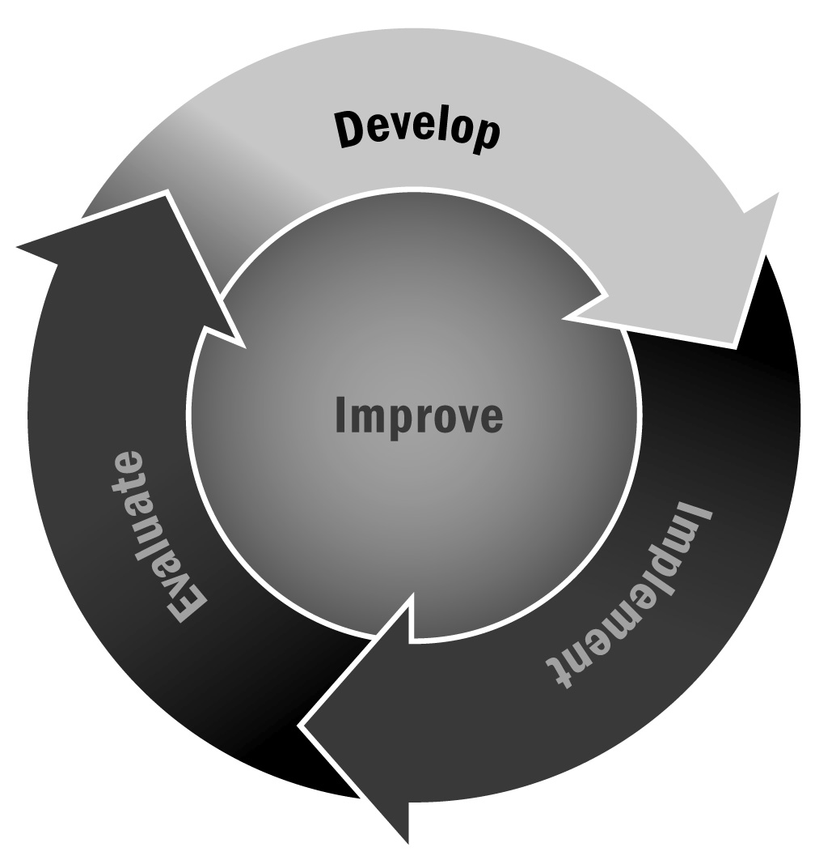
In Chapter 1, you learned that there are a variety of reasons staff members may be asked to share participant information and that it is important to establish policies and procedures to protect young people’s privacy and respect their rights as individuals. It is ideal to get “assent” or agreement from participants before sharing their information, whether informally or via a separate assent form. This is not a stand-alone document, and it needs to be accompanied by
a permission or consent form (e.g., Tool 10: Consent to Share Information).
Directions: Use this form to obtain assent or agreement from participants in your program to share their information. You should explain clearly the purpose of the assent and the consequences of signing the assent form to the young person. An assent form is not legally binding and should not take the place of a consent form.

ABC Program Participant Assent Form
You are being asked to help us by letting us share information about you. Your parents or guardian say it is okay, but it is up to you if you want to share your information, or not. If you want to know more about sharing information, you may ask us. You are not obligated to sign this form.
We will share the following information:
- [List information that will be shared]
Information will be shared with:
I understand what is being asked of me. Please sign below.
Yes, I will allow you to share my information.
No, I do not want you to share my information.
Date:
Name of Participant (please print):
Signature of Witness: |  |  |  |  | Date:

